
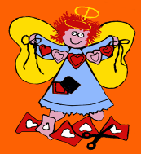
Holy Angels Pre-school
Child Friendly Safeguarding Policy

All the adults around you think that your health, safety, and welfare are important. We want you to feel safe and secure.
In our pre-school, we respect all children and help to protect your rights.
We want you to feel safe from harmful words and actions.
We do our best to help children make good educational and emotional progress.
We want to teach you how to recognise risks in different situations, and how to protect yourselves and stay safe.
How do we protect you at Holy Angels?
We provide a safe environment for you to develop, play and learn. We are a pre-school where everyone has the right to feel SAFE; the right to LEARN and the right to RESPECT.
We want to help ensure that you remain safe at home as well as at school.
If you are a pupil in our Lady of the Angels, we will talk to your teachers to let them know if you need support or want to talk to them.
We think it is important for you to know where to get help if you are worried or unhappy about something. You can talk to any adult in pre-school if you need to, just tell them what is worrying you.
You can also phone ChildLine who will listen to you and give you help and advice on 0800 1111.
