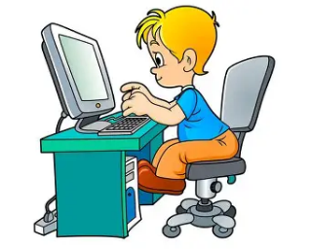

Holy Angels Pre-school

Child Friendly E-safety Policy
This child friendly e-safety policy has been developed with the aim to keep children safe on the internet at home and at school.
Why do we like the internet?
• It is interesting and fun.
• We can learn a lot from the internet.
• We use it for our school work.

What are the dangers of children going online?
• We could see or hear things that are not suitable for children.
• People on the internet can pretend that they are someone else.
• People could ask for personal information, which is dangerous.
• Not everybody on the internet is kind.

Why do we need an e-safety policy?
• To keep children safe whilst also having fun using the internet at home and at school.
• To make sure children know what to do if something on the internet makes them worried.

How does Holy Angels keep children safe when they use the internet at school?
• The grown-ups are always watching us when we use the internet at school.
• The grown-ups explain to us how to use the internet safely.
• Our school filters the search results so that it is ok for children to see.

If children have a problem when they are online what should they do?
• Keep calm and tell a grown up straight away.
• Stay on the page so a grown up can see what has made us feel worried/upset.
• Block and report anyone that is being unkind.

What should they not do?
• Do not keep worries to yourself.
• Do not be unkind back to anybody.
• Do not delete messages.
• Do not switch off the computer without telling a grown-up.

Our internet rules are:
• We ask permission before using the internet and we only use websites that a grown-up has told us to use.
• We never share our passwords with anyone else.
• We must never give anyone our personal information.
• We need to tell a grown up if we see or hear something that makes us upset or worried.
• We will never look for, save or send anything that could be unpleasant or nasty.

